ZONING SECTION STAFF REPORT
February 3n 2025
BOARD OF ADJUSTMENT PUBLIC HEARING

Case Number | 250201V
Type of Case | Variance In accordance with Section 2.9 of the Marion County Land Development Code, a reduction of the waterfront setback from 75’(feet) to 38.8’(feet) for the purposed 30X32 (feet) storage area building in a Single-Family Dwelling (R-1) zone.
AR | 32252
Owner | Daniel Gray
Applicant | Self/ Owner
Street Address | 12455 SE 135th Terrace, Ocklawaha, Florida
Parcel Number | 48764-000-00
Property Size | ±.40 acres
Future Land Use | Medium Residential Land Use
Zoning Classification | Single-Family Dwelling (R-1)
Overlay Zone/Scenic Area | Environmentally Sensitive Overlay Zone (ESOZ), FEMA Designated Flood Zone AE, and Secondary Springs Protection Zone (SSPZ).
Project Planner | Lynda Smith, Zoning Technician I
Permit | No active permits at this time

- ITEM SUMMARY

This is a request filed by applicant/owner Daniel Gray for a variance from Land Development Code (LDC) Section 2.9, a reduction of the waterfront setback from 75ft to 38.8ft for the purposed 30ft X 32ft storage area building, in a Single-Family Dwelling (R-1) zone. R-1 zoning has setbacks for accessory structures that are 8ft from the rear property line and 8ft from the side property lines except in an ESOZ zone where the front of the property faces the canal and setbacks are 75ft from the Ordinary High-Water Line (Safe Upland Line), 8ft from the rear property line and 8ft from the side property lines for accessory structures. The accessory structure in an R1 zoning must be either to the side of the SFR or to the rear of the SFR. The area of the proposed site is approximately 79ft in width. Proposed structure can meet the rear and side setbacks of 8ft but is unable to meet the front setback of 75ft from the Ordinary High Water Line (Safe Upland Line), which is not the same as the rear setback.

Timeline:

- This subdivision was platted on March 3, 1924
- Single-Family Residence was built in 1943
- ESOZ and Zoning regulations went into effect in 1992 with the adoption of the Marion County Land Development Code
- ESOZ Ordinary High Water Line regulations was changed in 2013 from 50ft to 75ft

Figure 1
General Location Map
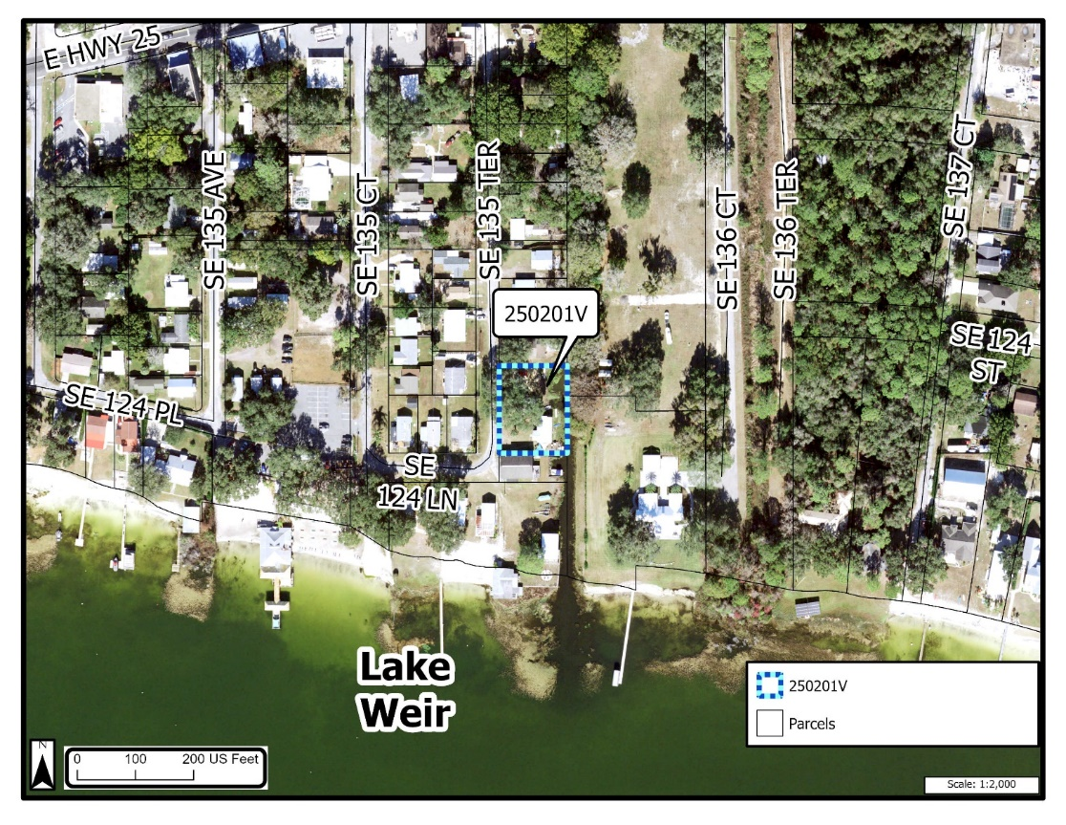

- PUBLIC NOTICE
Notice of the public hearing was mailed to 23 property owners within 300-feet of the subject property on January 17, 2025. A public notice sign was posted on the subject property on January 03, 2025, and notice of the public hearing was published in the Star Banner on January 20, 2025. Evidence of the public notice requirements are on file with the Department and are incorporated herein by reference.

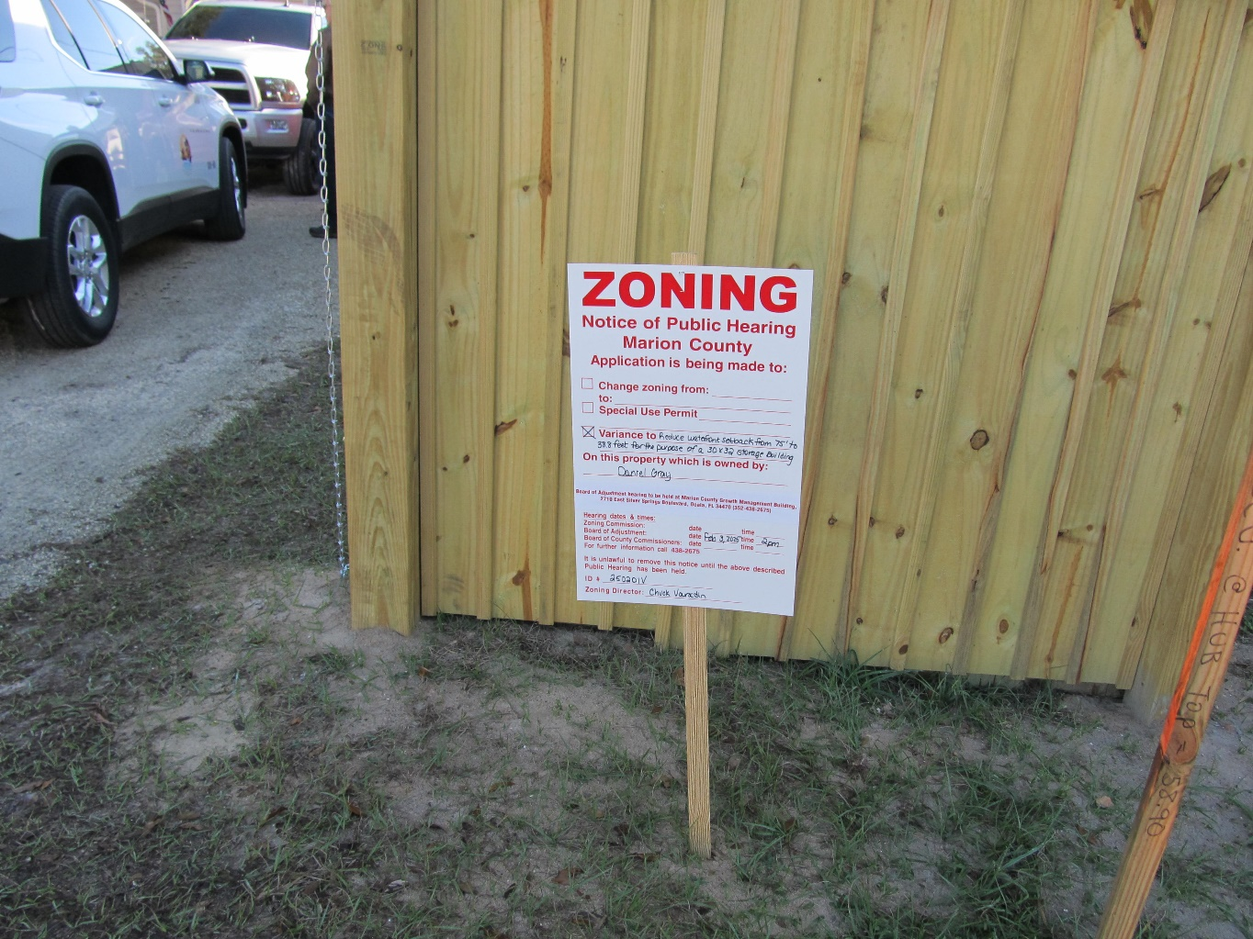

- PROPERTY CHARACTERISTICS
This parcel is ±.40-acres with Medium Residential land use (MR) and Single-Family Dwelling (R-1) zoning classification. This parcel also lies in an Environmentally Sensitive Overlay Zone (ESOZ), and FEMA Flood Zone “AE”.

Figure 2
Aerial
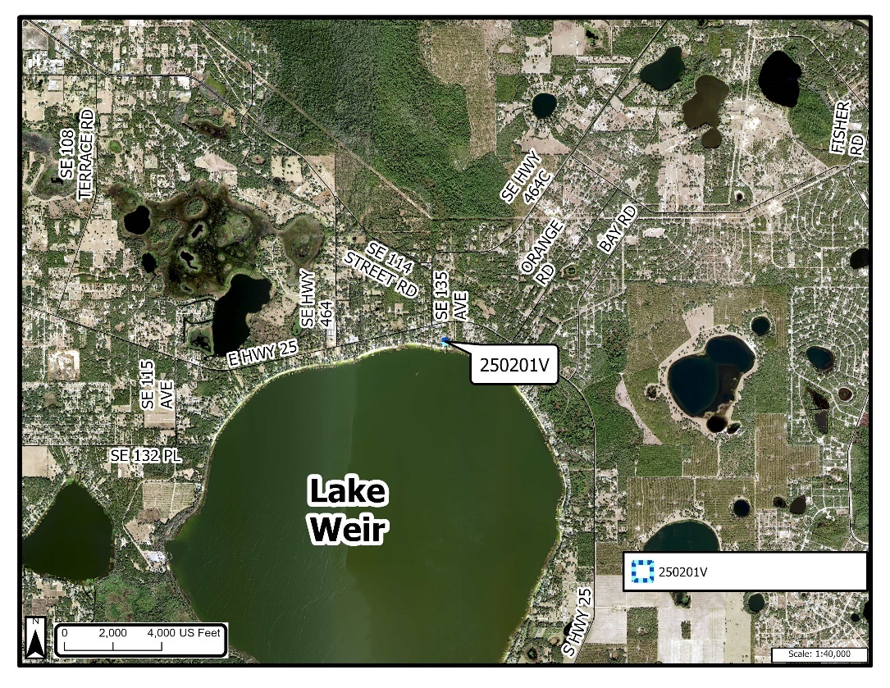
Figure 3
Zoning Map
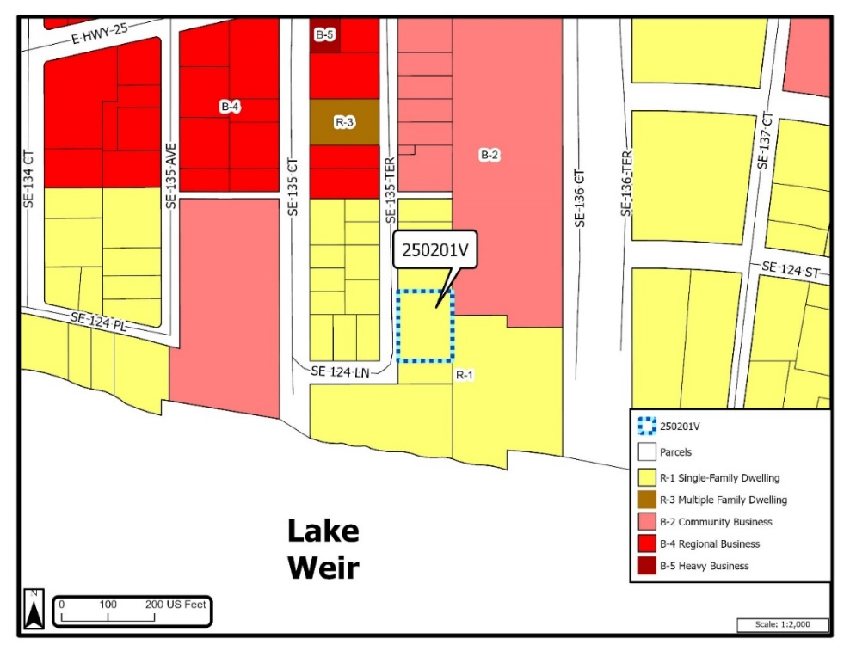

Figure 4
ESOZ AND Floodplain Map

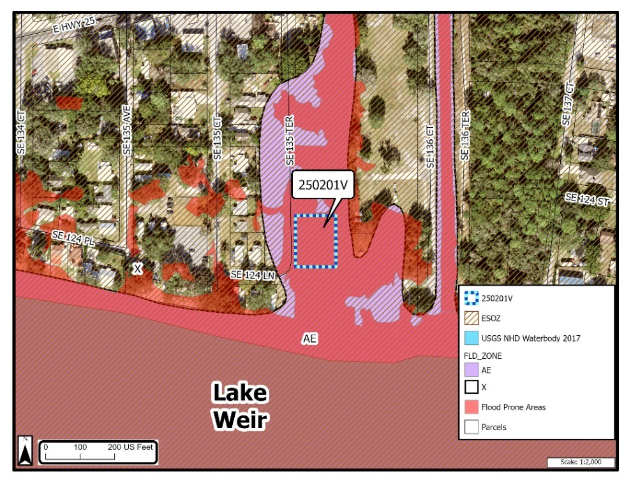

Figure 5
Land Use Map
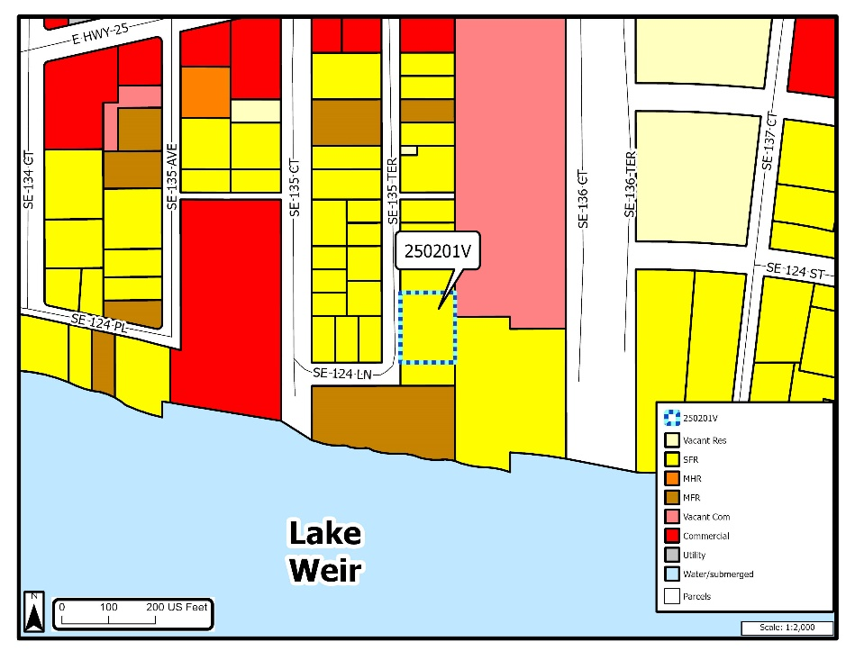

Figure 6
Surrounding Variances Map

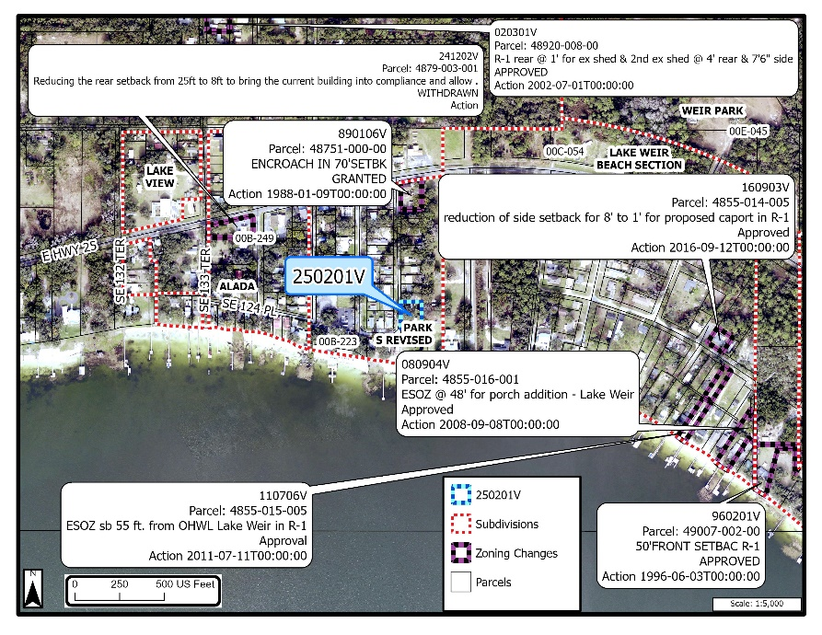
- REQUEST STATEMENT
Applicant/owner, Daniel Gray, requests a variance in accordance with Section 2.9 of the Marion County Land Development Code, a reduction of the waterfront setback from 75ft to 38.8ft for the purposed 30ft X 32ft storage area building, in a Single-Family Dwelling (R-1) zone. R-1 zoning has setbacks for accessory structures 8ft from the rear property line and 8ft from the side property lines except in an ESOZ zone in which the front setback is 75ft from the Ordinary High Water Line (Safe Upland Line), 8ft from the rear property line and 8ft from the side property lines for accessory structures.

Figure 7
Survey
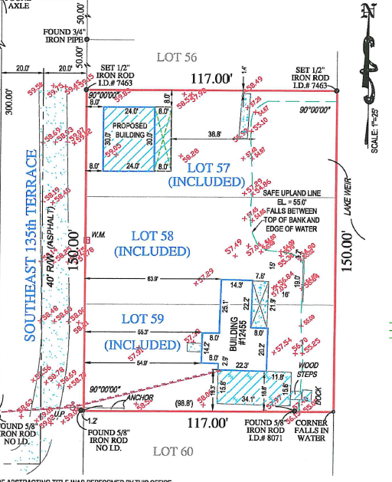

- ANALYSIS
LDC Section 2.9.2.E provides the Board of Adjustment shall not grant a variance unless the petition demonstrates compliance with the six (6) criteria. The six (6) criteria and staff’s analysis of compliance with those criteria are provided below.

- Special conditions and circumstances exist which are peculiar to the land, structure or building involved and which are not applicable to other lands, structures or buildings with the same zoning classification and land use area.

Analysis: In accordance to Section 2.9 of the Marion County Land Development
Code, a reduction of the waterfront setback from 75ft to 38.8ft at the canal side of
property in R-1 zoning classification for the placement of a 30ft X 32ft storage
building. Trees and other structures prohibit placement anywhere else. It is being
placed at the farthest point away from the canal and 8ft from the side property
line and 8ft roadside/rear property line.

Staff: Finds this subdivision was created March 3, 1924, prior to the ESOZ and Zoning regulations going into effect in 1992. ESOZ Ordinary High Water Line regulations was changed in 2013 from 50ft to 75ft This parcel currently has a SFR, built in 1943 and owners are wishing to build a storage building.

- The special conditions and circumstances do not result from the actions of the applicant.

Analysis: Applicant states trees and other structures were on property prior to considering placement of storage building.

Staff: The single-family residence was built in 1943, prior to the ESOZ and Zoning regulations going into effect. The special conditions and circumstances are not a result of the applicant. Most of the lots in this area do/will require a variance to be able to build structures on the surrounding lots/parcels due to size and ESOZ requirements.

3. Literal interpretation of the provisions of applicable regulations would deprive the applicant of rights commonly enjoyed by other properties with the same zoning classification and land use area under the terms of said regulations and would work unnecessary and undue hardship on the applicant.

Analysis: Applicant states that granting this variance would not be irregular to the surrounding area, this would not adversely affect any property owners

Staff: Finds that ESOZ and Zoning regulations went into effect in 1992. This single-family residence was built in 1943, prior to the regulations. Literal interpretations of the provisions of applicable regulations may deprive the applicant’s rights commonly enjoyed by other properties with the same zoning classification and land use.

4. The variance, if granted, is the minimum variance that will allow the reasonable use of the land, building or structure.

Analysis: Applicat states a reduction of 75ft from the canal Safe Upland Line (SUL) to 38.8ft from the canal SUL water line is the minimum needed in order to develop at the desired location

Staff: A reduction of the waterfront setback from 75ft to 38.8ft is the minimum variance that will allow the use of the land.

5. Granting the variance requested will not confer on the applicant any special privilege that is denied by these regulations to other lands, buildings or structures in the same zoning classification and land use area.

Analysis: Owner states that this is true. This request will not confer on the applicant any special privilege that is denied by these regulations to other lands, buildings or structures in the same zoning classification and land use area.

Staff: Finds that granting of the request will not confer on the applicant special privilege. Many parcels in these areas require ESOZ reductions because these parcels were created prior to the ESOZ regulations going into effect.

6. The granting of the variance will not be injurious to the neighborhood or otherwise detrimental to the public welfare.

Analysis: Owner states that this is true. Granting of the variance will not be injurious to the neighborhood or otherwise detrimental to the public welfare

Staff: Finds that if the variance is granted, it would not be injurious to the neighborhood as long as the applicant pulls the correct permits and gets them approved.

- LIST OF ATTACHMENTS

- Application
- Marion County Property Appraiser Property Record Card, 2024 Certified Assessment Roll
- Site Plan
- Deed
- 300’ Mailing Map
- Aerial View
- Photos

