ZONING SECTION STAFF REPORT
February 3, 2025
BOARD OF ADJUSTMENT PUBLIC HEARING

Case Number | 250202V
CDP-AR | 32211
Type of Case | Variance to reduce ESOZ waterfront setback from 75’ to 49’ for a proposed screened porch in a Mixed Residential (R-4) zone.
Owner | Scott Hill and Terri Cason Blocker
Applicant | Scott Hill Blocker
Street Address | 18632 NE 238th Ave, Ft. McCoy
Parcel Number | 05664-001-05
Property Size | ±0.24 ac
Future Land Use | Rural Land (RL)
Zoning Classification | Mixed Residential (R-4)
Overlay Zone/Scenic Area | Environmentally Sensitive Overlay Zone (ESOZ) and Secondary Springs Protection Overlay Zone (SPOZ)
Project Planner | Cristina Franco, Zoning Technician I
Related Case(s) | None

- ITEM SUMMARY

This is a request filed by the applicant/owner Scott Blocker, for a variance from Land Development Code (LDC) Section 5.2.4.A to reduce the Environmentally Sensitive Overlay Zone (ESOZ) waterfront setback from 75’ to 49’ for a proposed 16 x 24 screened porch. R-4 setback for the rear and front is 25’ but ESOZ setback supersedes the R-4 typical setback.

Figure 1 is an aerial photograph displaying the general location of the subject property. Due to ESOZ the waterside is considered the front.
Figure 1
General Location Map

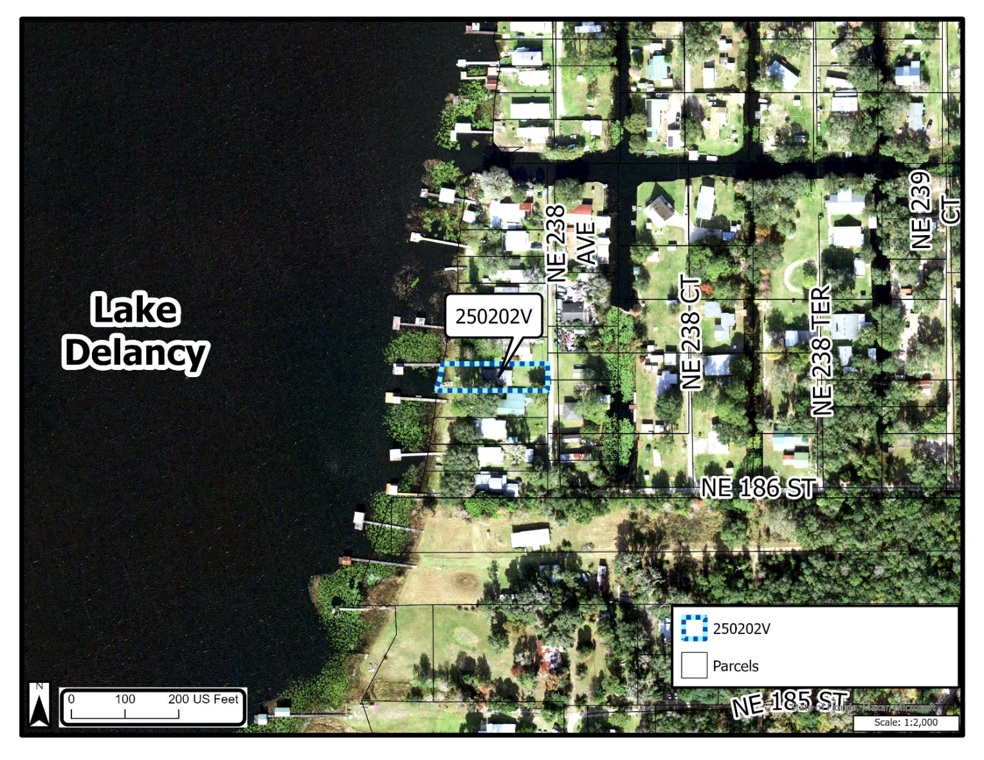
PUBLIC NOTICE
Notice of public hearing was mailed to (23) property owners within 300-feet of the subject property on January 17, 2025. A public notice sign was posted on the subject property on January 7, 2025 and notice of the public hearing was published in the Star Banner on January 20, 2025. Evidence of the public notice requirements are on file with the Department and are incorporated herein by reference.

- PROPERTY CHARACTERISTICS
This parcel is located in the unrecorded subdivision of Lake Delancy Heights which was established in 1970 and the house was built in 1990. The subject property is ±0.24 acres, located within the Rural Future Land Use Map Series (FLUMS) designation, and has a Mixed Residential (R-4) zoning classification. The property is also located in an Environmentally Sensitive Overlay Zone (ESOZ) fronting on Lake Delancy (See Figure 2).

Timeline:
- This subdivision was platted on 1970.
- Single-Family Residence was built in 1990.
- ESOZ and Zoning regulations went into effect in 1992 with the adoption of the Marion County Land Development Code
- ESOZ Ordinary High Water Line regulations was changed in 2013 from 50ft to 75ft

Figure 2
Aerial
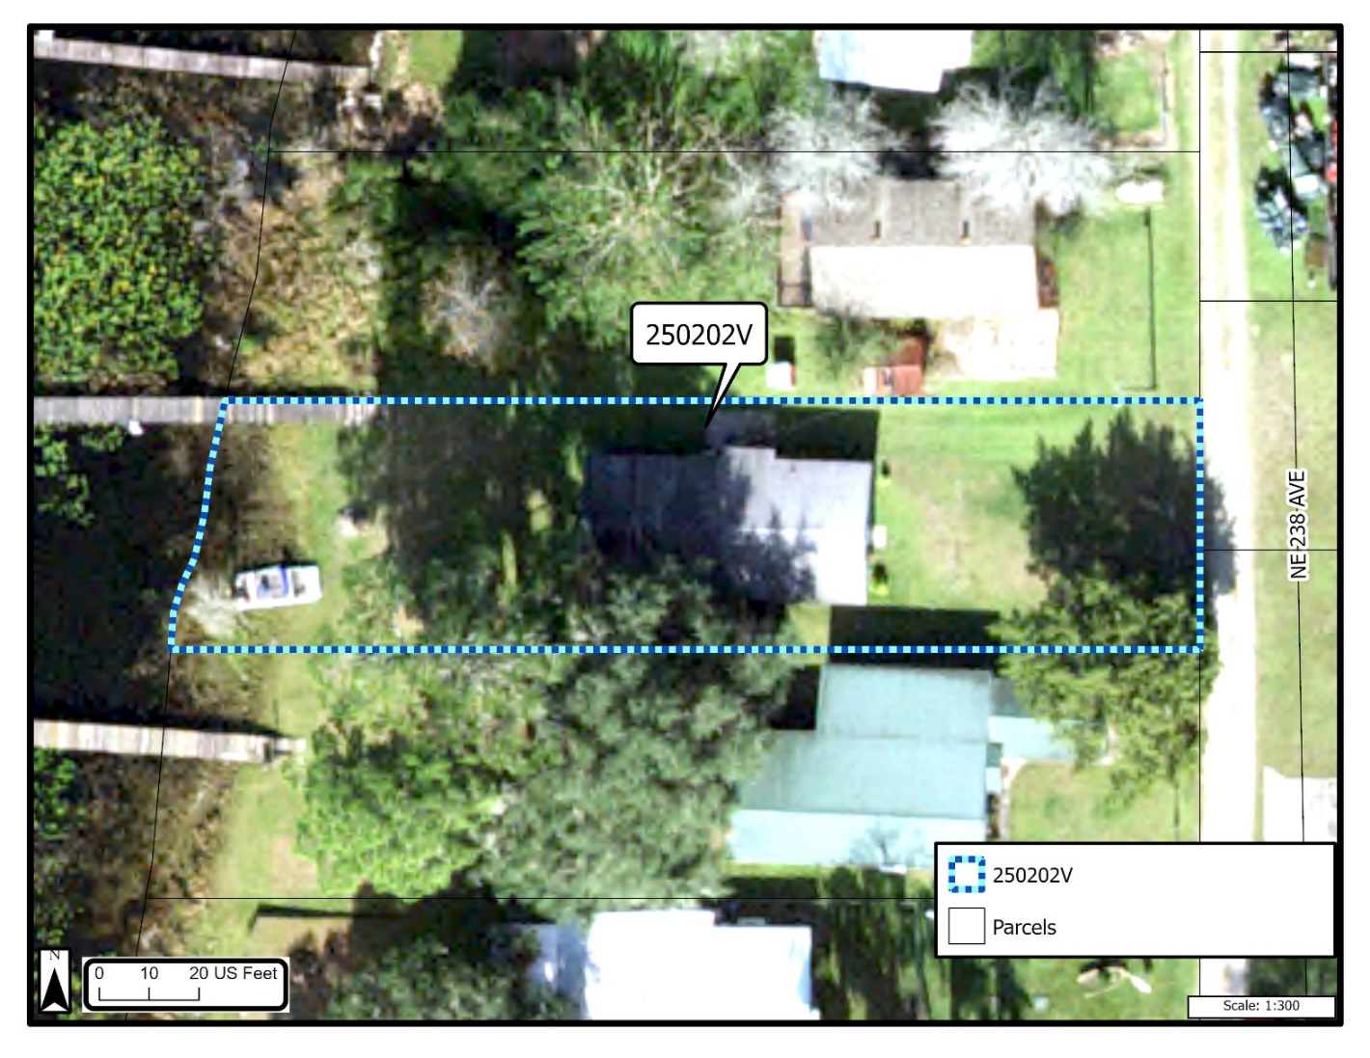

Figure 3
Survey of Property
(Attachment C)
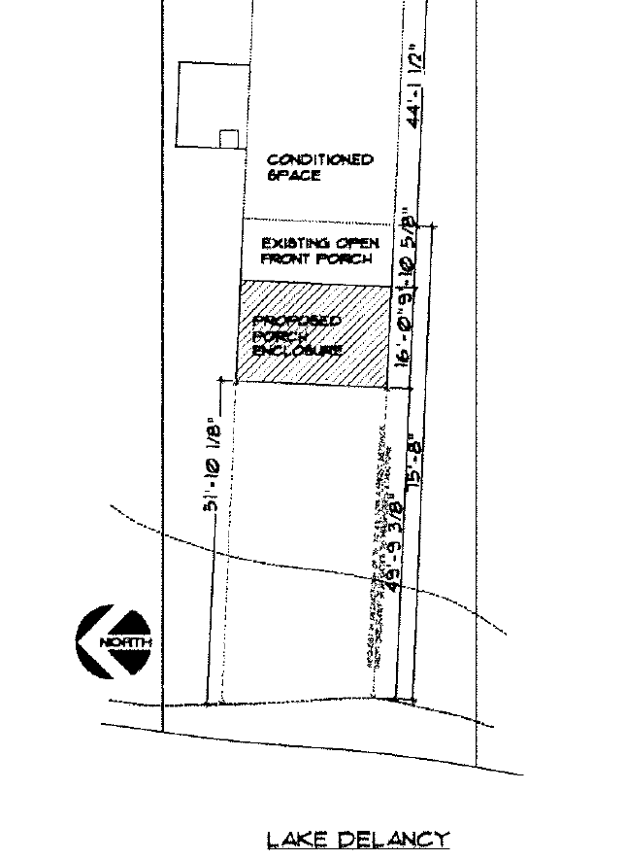

- REQUEST STATEMENT
Owner/applicant Scott and Terri Blocker requests a variance from LDC Section 5.2.4.A., to reduce the west ESOZ waterfront setback line from 75’ to 49’ for proposed screened porch in (R-4) Zoning.

ANALYSIS
LDC Section 2.9.2.E provides the Board of Adjustment shall not grant a variance unless the petition demonstrates compliance with the six (6) criteria. The six (6) criteria and staff’s analysis of compliance with those criteria are provided below.

- Special conditions and circumstances exist which are peculiar to the land, structure or building involved and which are not applicable to other lands, structures or buildings with the same zoning classification and land use area.

Analysis: The Applicant states he needs to reduce ESOZ front setback from 75’ to 49’ for a proposed screened porch. The perimeter of the house has remained unchanged since 1973. “We have the opportunity to enjoy the house and the lake in a way where it has not been possible in the past. We would like to take advantage of it. This property, although not luxurious, is a place for our entire family to continue to create memories”.

Staff finds that there are special conditions and circumstances which are peculiar to the land, structure or buildings involved and which are applicable because ESOZ requirements were implemented in 1992 and changed again in 2013 after the subdivision was created in 1970 and the house was built in 1990.

- The special conditions and circumstances do not result from the actions of the applicant.

Analysis: The purpose to this application is to gain the ability to enjoy the outdoor views of Lake Delancy without the limitations of the current conditions of the existing porch. The house was built in 1973. We expect it to remain in family ownership permanently. A second reason for the application is having the ability to gather as a family within the same space. That is currently not possible. We have the opportunity to have a large enough common space to gather as a family. The expansion of the existing porch will not be injurious to the neighborhood, or otherwise detrimental to the public welfare.

Staff finds the special conditions and circumstances do not result from the actions of the applicant. Instead, they result from LDC requirements pertaining to the minimum ESOZ setback of 75’ from the ordinary high waterline for all structures.

3. Literal interpretation of the provisions of applicable regulations would deprive the applicant of rights commonly enjoyed by other properties with the same zoning classification and land use area under the terms of said regulations and would work unnecessary and undue hardship on the applicant.

Analysis: Granting this variance would not be irregular to the surrounding area. This would not adversely affect any property owners. In fact, many of the surrounding areas have buildings much closer to the water than the proximity which I propose under this application.

Staff finds that granting this variance would not be irregular to the surrounding area and would not adversely affect any property owners.

4. The variance, if granted, is the minimum variance that will allow the reasonable use of the land, building or structure.

Analysis: A reduction of 75’ to 49’ for a front setback from the ordinary high-water line to the proposed structure is the minimum needed in order to develop at the desired location. Please also consider that there is a considerable difference in elevation (50’’) from the current water level as well as the ordinary water elevation to our proposed addition.

Staff finds that, the existing front porch which is 10’ is existing in the ESOZ setback. An ESOZ plan will be required to prevent stormwater runoff from directly entering Lake Delancy.

5. Granting the variance requested will not confer on the applicant any special privilege that is denied by these regulations to other lands, buildings or structures in the same zoning classification and land use area.

Analysis: This statement is correct and applicable to my property.

Staff finds that granting of the request will not confer on the applicant any special privilege because the surrounding lots also have homes located in the same area and many of them were granted some sort of reduced setbacks for development similar to that being requested.

Figure 4
Map Showing Variances in the Area

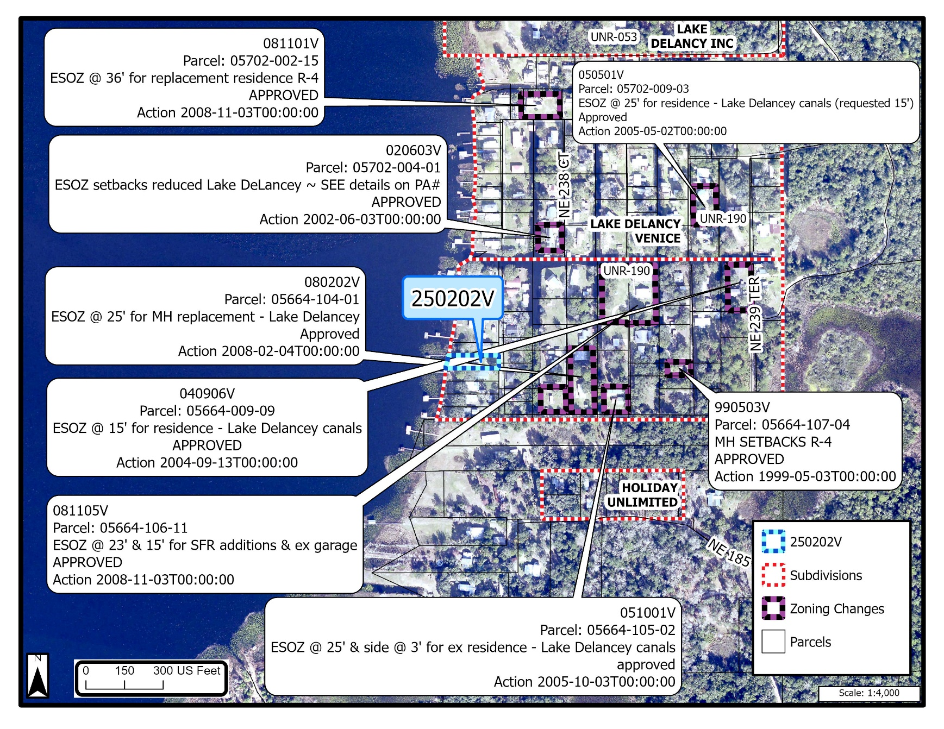

6. The granting of the variance will not be injurious to the neighborhood or otherwise detrimental to the public welfare.

Analysis: This statement is correct and applicable to my property.

Staff finds that if variance is granted, it would not be injurious to the neighborhood as long as the applicant pulls the correct permits and gets them approved.

- LIST OF ATTACHMENTS

- Application
- Marion County Property Appraiser Property Record Card, 2024 Certified Assessment Roll
- Site Plan
- Deed
- 300’ Mailing Map
- Aerial View
- Photos

